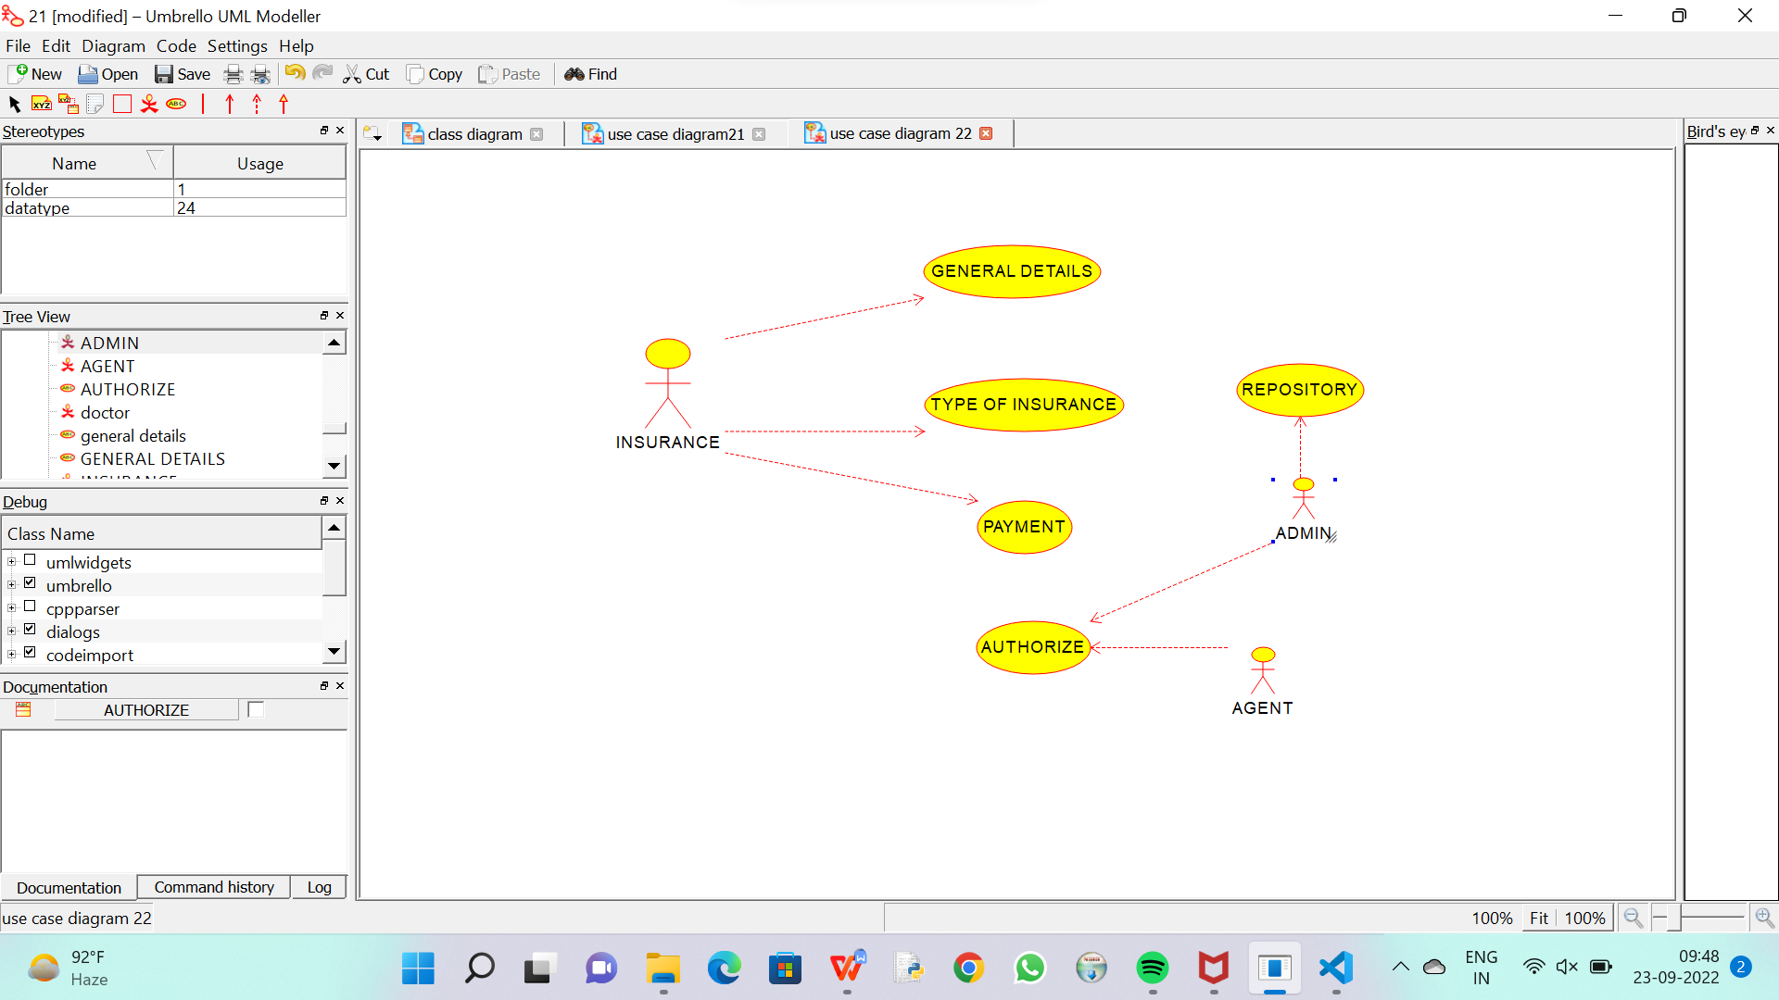

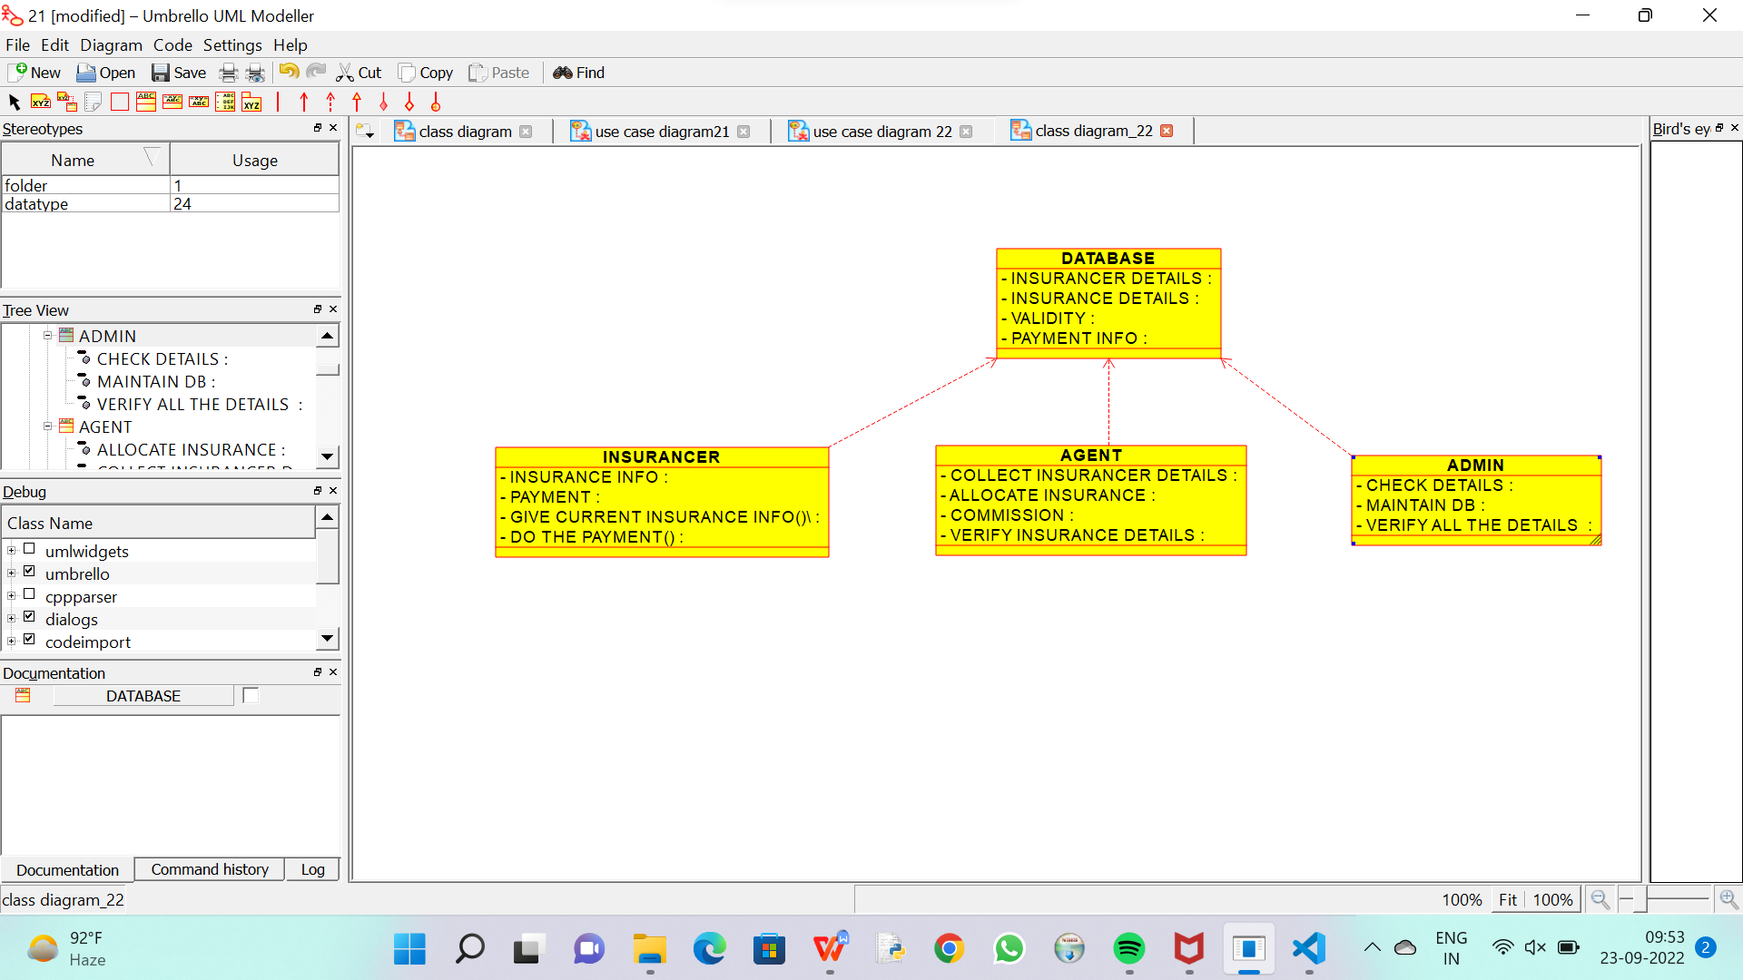

CODE FOR AGENT :

/**

 * Class AGENT

 */

public class AGENT {

  //

  // Fields

  //

  private void COLLECT_INSURANCER_DETAILS;

  private void ALLOCATE_INSURANCE;

  private void COMMISSION;

  private void VERIFY_INSURANCE_DETAILS;

  //

  // Constructors

  //

  public AGENT () { };

  //

  // Methods

  //

  //

  // Accessor methods

  //

  /**

   * Set the value of COLLECT_INSURANCER_DETAILS

   * @param newVar the new value of COLLECT_INSURANCER_DETAILS

   */

  private void setCOLLECT_INSURANCER_DETAILS (void newVar) {

    COLLECT_INSURANCER_DETAILS = newVar;

  }

  /**

   * Get the value of COLLECT_INSURANCER_DETAILS

   * @return the value of COLLECT_INSURANCER_DETAILS

   */

  private void getCOLLECT_INSURANCER_DETAILS () {

    return COLLECT_INSURANCER_DETAILS;

  }

  /**

   * Set the value of ALLOCATE_INSURANCE

   * @param newVar the new value of ALLOCATE_INSURANCE

   */

  private void setALLOCATE_INSURANCE (void newVar) {

    ALLOCATE_INSURANCE = newVar;

  }

  /**

   * Get the value of ALLOCATE_INSURANCE

   * @return the value of ALLOCATE_INSURANCE

   */

  private void getALLOCATE_INSURANCE () {

    return ALLOCATE_INSURANCE;

  }

  /**

   * Set the value of COMMISSION

   * @param newVar the new value of COMMISSION

   */

  private void setCOMMISSION (void newVar) {

    COMMISSION = newVar;

  }

  /**

   * Get the value of COMMISSION

   * @return the value of COMMISSION

   */

  private void getCOMMISSION () {

    return COMMISSION;

  }

  /**

   * Set the value of VERIFY_INSURANCE_DETAILS

   * @param newVar the new value of VERIFY_INSURANCE_DETAILS

   */

  private void setVERIFY_INSURANCE_DETAILS (void newVar) {

    VERIFY_INSURANCE_DETAILS = newVar;

  }

  /**

   * Get the value of VERIFY_INSURANCE_DETAILS

   * @return the value of VERIFY_INSURANCE_DETAILS

   */

  private void getVERIFY_INSURANCE_DETAILS () {

    return VERIFY_INSURANCE_DETAILS;

  }

  //

  // Other methods

  //

}

CODE FOR DATABASE :

/**

 * Class DATABASE

 */

public class DATABASE {

  //

  // Fields

  //

  private void INSURANCER_DETAILS;

  private void INSURANCE_DETAILS;

  private void VALIDITY;

  private void PAYMENT_INFO;

  //

  // Constructors

  //

  public DATABASE () { };

  //

  // Methods

  //

  //

  // Accessor methods

  //

  /**

   * Set the value of INSURANCER_DETAILS

   * @param newVar the new value of INSURANCER_DETAILS

   */

  private void setINSURANCER_DETAILS (void newVar) {

    INSURANCER_DETAILS = newVar;

  }

  /**

   * Get the value of INSURANCER_DETAILS

   * @return the value of INSURANCER_DETAILS

   */

  private void getINSURANCER_DETAILS () {

    return INSURANCER_DETAILS;

  }

  /**

   * Set the value of INSURANCE_DETAILS

   * @param newVar the new value of INSURANCE_DETAILS

   */

  private void setINSURANCE_DETAILS (void newVar) {

    INSURANCE_DETAILS = newVar;

  }

  /**

   * Get the value of INSURANCE_DETAILS

   * @return the value of INSURANCE_DETAILS

   */

  private void getINSURANCE_DETAILS () {

    return INSURANCE_DETAILS;

  }

  /**

   * Set the value of VALIDITY

   * @param newVar the new value of VALIDITY

   */

  private void setVALIDITY (void newVar) {

    VALIDITY = newVar;

  }

  /**

   * Get the value of VALIDITY

   * @return the value of VALIDITY

   */

  private void getVALIDITY () {

    return VALIDITY;

  }

  /**

   * Set the value of PAYMENT_INFO

   * @param newVar the new value of PAYMENT_INFO

   */

  private void setPAYMENT_INFO (void newVar) {

    PAYMENT_INFO = newVar;

  }

  /**

   * Get the value of PAYMENT_INFO

   * @return the value of PAYMENT_INFO

   */

  private void getPAYMENT_INFO () {

    return PAYMENT_INFO;

  }

  //

  // Other methods

  //

}

CODE FOR INSURANCER :

/**

 * Class INSURANCER

 */

public class INSURANCER {

  //

  // Fields

  //

  private void INSURANCE_INFO;

  private void PAYMENT;

  private void GIVE_CURRENT_INSURANCE_INFO_;

  private void DO_THE_PAYMENT_;

  //

  // Constructors

  //

  public INSURANCER () { };

  //

  // Methods

  //

  //

  // Accessor methods

  //

  /**

   * Set the value of INSURANCE_INFO

   * @param newVar the new value of INSURANCE_INFO

   */

  private void setINSURANCE_INFO (void newVar) {

    INSURANCE_INFO = newVar;

  }

  /**

   * Get the value of INSURANCE_INFO

   * @return the value of INSURANCE_INFO

   */

  private void getINSURANCE_INFO () {

    return INSURANCE_INFO;

  }

  /**

   * Set the value of PAYMENT

   * @param newVar the new value of PAYMENT

   */

  private void setPAYMENT (void newVar) {

    PAYMENT = newVar;

  }

  /**

   * Get the value of PAYMENT

   * @return the value of PAYMENT

   */

  private void getPAYMENT () {

    return PAYMENT;

  }

  /**

   * Set the value of GIVE_CURRENT_INSURANCE_INFO_

   * @param newVar the new value of GIVE_CURRENT_INSURANCE_INFO_

   */

  private void setGIVE_CURRENT_INSURANCE_INFO_ (void newVar) {

    GIVE_CURRENT_INSURANCE_INFO_ = newVar;

  }

  /**

   * Get the value of GIVE_CURRENT_INSURANCE_INFO_

   * @return the value of GIVE_CURRENT_INSURANCE_INFO_

   */

  private void getGIVE_CURRENT_INSURANCE_INFO_ () {

    return GIVE_CURRENT_INSURANCE_INFO_;

  }

  /**

   * Set the value of DO_THE_PAYMENT_

   * @param newVar the new value of DO_THE_PAYMENT_

   */

  private void setDO_THE_PAYMENT_ (void newVar) {

    DO_THE_PAYMENT_ = newVar;

  }

  /**

   * Get the value of DO_THE_PAYMENT_

   * @return the value of DO_THE_PAYMENT_

   */

  private void getDO_THE_PAYMENT_ () {

    return DO_THE_PAYMENT_;

  }

  //

  // Other methods

  //

}